Norwegian Environment Agency
EIA database development for NEMA Uganda
System specification, version 0.9
Christian Haugland, Torstein Finnesand and Jostein Skaar
16.05.2014

EIA database development description.

1. Project description 3
2. Steps in the EIA review process 3
2.1 Screening 4
2.2 EI Study 4
2.3 Decision 4
3. The current EIA-database 4
3.1 Structure and data 4
3.2 Re-use 5
4. Infrastructure and users 6
4.1 Infrastructure, application and hardware 6
4.2 Users of the system. Roles 7
5. The new database 7
5.1 Database model 7
5.2 The projects table 9
5.3 The organisations table 9
5.4 The audits_inspections table 10
5.5 The eias_permits table 10
5.6 The documents table 11
5.7 The hearings table 11
5.8 The practitioners table 12
5.9 The practitioner_certificates table 12
5.10 The audits_inspections_personnel table 12
6. Using the database in the processes 12
6.1 Practitioners 12
6.2 Enter data for EIA and Permits 13
6.3 The EIA process status 16
6.4 The Audit and Inspection process 18
6.5 The Audit and Inspection status 19
6.6 Support tables 19
7. Search 20
7.1. Why search? 20
7.2. Audit and inspections 20
7.3. EIA and permits 21
8. Statistics 22
8. Follow up 22
8.1 Documents 22
8.2 Permits 23
8.3 Audits done by the project (the organisations) 23
8.4 Laboratory 23
8.5 External support/maintenance 23
9. Appendix 25
9.1 Hosting database in the cloud 25
9.2 Process description 26
9.3 Database model 27
9.4 The codes table 28

1. Project description
The National Environment Management Authority (NEMA) is requesting assistance in improving its use of IT to support work processes dealing with project specific EIAs. Important goals are:
- Improve access to relevant data for the NEMA employees.
- Facilitate monitoring of the internal work processes.
- Improve access to relevant documents.
- Facilitate update of list of certified and registered EIA practitioners.
- Facilitate communication with external parties involved in the work processes, including other government authorities.
- Facilitate compliance monitoring.
- Strengthen capacity for providing information to the general public.

To achieve these goals there is a need to build a new system (database + application), by using modern IT-principles. The structure of the database and the design of the application will be based on:
- Ugandan regulations and guidance.
- Meetings in Kampala and Oslo.
- The existing EIA database.
- Feedback from the key prospective users of the system (by way of email).

The system will be developed in cooperation between NEMA and The Norwegian Environmental Agency.
The main participants in the project are:

Margaret Aanyu EIA coordinator NEMA
Isaac I. G. Ntujju Senior Environmental Inspector NEMA
Kato Phillip Network administrator NEMA
Christian Haugland System manager The Norwegian Environment Agency
Torstein Finnesand System manager The Norwegian Environment Agency
Jostein Skaar IT-Developer The Norwegian Environment Agency

Other participants will also contribute, especially in giving insights regarding the EIA process and the different registrations made in the EIA database.

The development of the application will be done in steps.

The goal is to have a first version ready by June 2014. This first version will contain registrations of the first two steps defined below. In addition this version may also facilitate update of the table of all EIA practitioners that is approved by NEMA.

The application will be further developed, adding on new functionality, during the fall of 2014.

After the database is in place, the intention is that NEMA will take over the maintenance of the system.

2. Steps in the EIA review process
The EIA process is divided into three stages; screening, EIA study and finally decision making. The process starts when NEMA receives a submitted project brief (PB) from a developer. Project briefs are concise documents (20 pages) that should contain contact details of the developer, characteristics of the project and characteristics of the potential environmental impacts. A given PB is forwarded to the relevant lead agency (and other agencies with stakeholder interests) before the screening process starts.

2.1 Screening
The purpose of a screening process is to determine whether a project needs an EIS. If the project does not have significant impact on the environment, a certificate may be issued based solely on the Project brief. When the NEMA receives a PB, it will consult with the lead agency and other stakeholder agencies and the hearing process will result in one of two possible decisions:
- The project is exempted from the requirement to undergo a full EIA. If this is the case a certificate can be issued.
- The project is required to have to undergo a full EIA. This will initiate a scoping and submission of TOR (Terms of Reference) and finally an EIS.

2.2 EI Study
If a project is required to submit an Environmental Impact Statement (EIS), the developer needs to determine the scope of work to be done in the Environmental Impact Study (EIS) of the project. The EIS needs to be conducted by a third party, hired by the developer and pre-approved by NEMA. The list of approved practitioners can be obtained on the NEMA web site.
The developer will then submit a Term of reference (ToR) to NEMA. The ToR is sent to implicated lead agency, other stakeholder agencies and local governments for comments. If the ToR is accepted, the developer will conduct an Environmental Impact Assessment (EIA) resulting in an Environmental Impact Statement (EIS). This statement is then sent to NEMA for processing.

2.3 Decision
After the EIS is submitted, the EIS is sent on hearing to the lead agency and other stakeholder agencies and local governments. There can also be a public hearing depending on the magnitude of the project. NEMA then decides on whether the project in question will be approved or not. The processing of the EIS may have three possible outcomes:
- Approved – the EIS results in a certificate
- Rejected – the EIS is not approved and no certificate is issued
- Disregarded

If a project is approved, the developer needs to pay a fee and provide an electronic version of the Environmental Impact Statement, before the certificate is issued.

3. The current EIA-database

3.1 Structure and data
NEMA already has a database for registering some information relevant for the EIA process. The structure consists of the following five tables (based on a copy received in December 2012), where data have been recorded:
- Proponent – includes data regarding registration of customer/developer.
- Project – the central table with information of project name and category.
- Location – registrations of project location including coordinates.
- EIA – information on dates and decisions.
- Consultant – information on hired consultants for different projects.

The field names and the number of data entries are shown below in Figure 1.

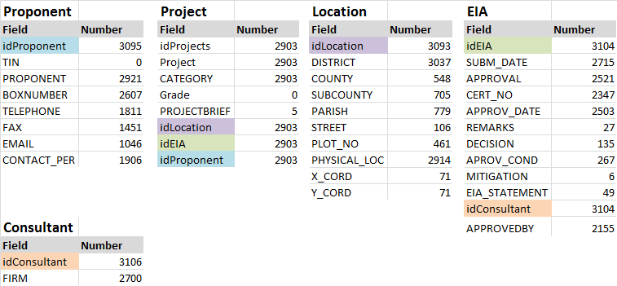
Figure 1. The existing database tables indicating relations.

3.2 Re-use
The existing database has a flat structure between the tables. The consequence is that information is duplicated. Also, the information is often registered in different ways in different tables. In the Consultant table is for instance, the same consultant has been named in the following variants:
- "Gissat Environment Associate" 40 times,
- "Gissat Environment Associates, Environment & Development Management Consults, Plot 3334, UDC Close Off Kironde Rd, Muyenga, Tel./Fax 246-4141-267078/0772-403796, P.O BOX 21598, Kampala" 68 times,
- "Harriet Mujuni_Gissat Environment Associates" 20 times and
- "Gissat Environment Associates (Harriet Mujuni)" 13 times.

It would have been easier for NEMA to make use of the data if the consultants name were registered only once. Registering only once would save time as well.

The problem of multiple data registration appears in the Proponent table as well. For instance is "Warid Telecom Uganda Ltd" registered 398 times. The database should be designed in such a way that one registration of this kind of information would be sufficient.

Each project seems to have one location, and vice versa. We suggest therefore that a separate Location table should not be part of the new data base, and that fields concerning location should instead be stored in the Project table.

The main information on the Location table is District and physical location. District is vital and very useful information in the database. The table has 187 unique districts. The reason for this high number is that some districts (2 %) seem to include several names, like "Buliisa, Amuru & Nebbi" and different spellings like "Masindi" and "Masindia". It is probably better to register only one district for a project in the new database. When a project is located in several districts, it is probably most important to identify one district as the main district, register the project in this one. Alternatives for informing that the project is a cross-district project need to be considered and if necessary be decided.

71 locations have coordinates. It seems that coordinates were recorded at a late stage, since locations with a high ID number tend to have coordinates. We don't now the quality of the coordinates, but maybe they could be checked before they are eventually imported to (or registered in) the new database.

The Consultant table has different kinds of information in the same field. The field is called "FIRM" and examples are:
- "Biljoss Consultants: Dr. Anrew Muwanga; Dr. Natal Ayiga; and Prof. Gaddi Ngirane-Katashaya. Contact: Dr. Muwanga, Makerere University, P.O. Box 7062, Kampala. Tel: 256 41-541258"
- "Eddie Luyima (Eco & Partner Consult, P.O. Box 23989 KAMPALA Tel.: 256-077 669601); and Robert Kasande (P.O. Box 27955 KAMPALA Tel.: 077402993)"

We suggest that the new database has several fields for this information, - which would make it easier to check and use the information. We suggest that the fields should be more or less the same as the field Isaac Ntujju uses in his practitioners document. It is better to fill the new tables with information from Isaac's document instead of the information in the Consultant table.

The Proponent table has 2921 rows with information (name of organisations), although duplicated. Around 200 rows contain additional information (box number, phones, contact person) as well.

The Project table is the key table. Of the 2903 project entries, 2283 have information about proponent, EIA and Location.

The main question seems to be whether NEMA would find it useful to transfer those 2283 record to the new database. If yes, we can study the data somewhat more, - in order to conclude what has to be done to do that. If yes, one thing that has to be done, is to remove all the duplicates in the Proponent table.

4. Infrastructure and users

4.1 Infrastructure, application and hardware
NEMA needs a server to host the new database, web application and storage for uploaded documents (files).

It is proposed that the database will be based on MySql running on Linux Ubuntu and that the application will be coded in PHP. This solution is open source and will not generate a licence fee. Employing this kind of solution is also a well-known strategy in the system development community so it should be easy recruiting people for taking care of system maintenance and adjustments in the future.

The web application will also give easy access from outside of NEMA's domain.

NEMA needs scanners to digitize documents as well. We suggest buying three scanners, one for the Registry, one for scanning certificates and one large scanner for digitizing old EIA reports (see chapter 7.1)

The database and web application will, for a period to be agreed, be hosted in the Amazon Cloud with support from the Trondheim office of the Norwegian Environment Agency (cf. the letter of approval, titled Hosting database in the cloud, signed by the Executive Director of NEMA September 24, 2013).

Existing data needs to be "washed" before they are uploaded to the new database. This process will take time and will require the dedication of adequate resources. A solution could be to import most of or all the data and "wash" them in the new or upgraded database. Since there will be a lot of new fields that are not present in the old database, the import date will act as a trigger for mandatory fields. A consequence of this is that old data cannot have mandatory fields, whereas new registrations will.

4.2 Users of the system. Roles
NEMA estimates approx. 25 users of the system. These are staff involved in the EIA review process and follow-up work like compliance monitoring. They all have access to a computer. NEMA already has an active directory (AD) installed and in use. However, we foresee potential issues with integrating the AD in the new system because it's location in the "cloud".

Our suggestion is therefore to add a User table to the database to handle logon requests. An administrator will generate a password, but this password may be changed by the user.

A role is a right to enter or change data in one or several data fields. Different users will have different roles according to their tasks in the process. The following role structure can be applied:
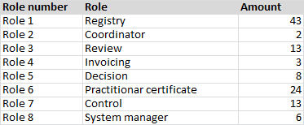
Figure 2. The different roles with proposed names and how many fields available for the role.

In addition to the proposed roles, there will be created a Read-only role. This role can search and export data (most users may make use of this role and it may include visitors to the Library's EIA Centre at NEMA House).

A person may have more than one role.

5. The new database

5.1 Database model
At the moment, the new database contains fifteen tables (shown in 8.3 Database model). Some are support tables and some are considered main tables. Support tables contain information used for registration. Registration of new project data will be stored in main tables. All fields in the different tables are shown in Figure 3. The proposed tables are:

- 'projects' – contains information about the facility or activity that NEMA wants to regulate or control. A project has a location and is normally located in one district. A project belongs to one category.
- 'organisations' – contains information about the developer (company information). The table is connected to 'projects' with "a one to many" relation. One developer can have several projects, but a project can only have one organisation.
- 'audits_inspections' – contains information about the audits and inspections NEMA carry out. The table is connected to project. A project can have several audits or inspections.
- 'eias_permits' – contains information about the process ending up in (normally) issuing of a certificate, and probably the permits/licences as well. The table is connected to 'projects', 'documents' and 'practitioners'. A project can have several certificates (for instance if a factory wants to increase its production) and several permits. One certificate can have several documents, but only one project.
- 'documents' – contains information related to the different types of documents that NEMA receives. The table is connected to 'eias_permits', 'hearings' and probably 'audits_inspections'. Since there will be different types of documents leading up to an EIA certificate, the information need to be stored in an own table.
- 'hearings' – contains information about the hearing process. The table is connected to 'document'.
- 'practitioners' – contains information about the EIA practitioners (the persons). The table is connected to 'practitionerCertificates' and 'eias_permits'.
- 'practitionerCertificates' – contains information about the certificates. The table is connected 'practitioners' since a practitionare can have several certificates. Could be two for each year.

Figure 3. New database structure with relations.

Figure 4 shows the number of fields allocated to the different tables. A total of 146 data fields are identified, distributed in 13 tables. The tables are categorized in main- and support tables.

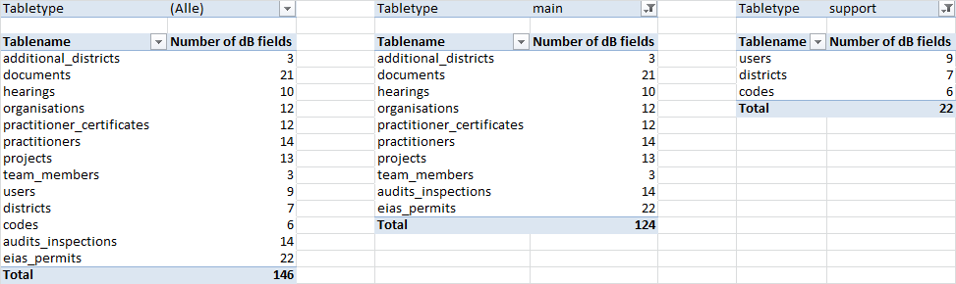
Figure 4. Total number of data fields for each table.

MÅ OPPDATERES!The main tables, with exception of the two small tables additional_districts and team_member, are shown in detail in following chapters.

5.2 The projects table
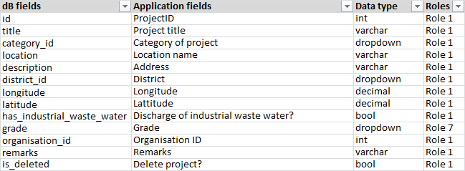
Figure 5. The project table with fields, proposed application fields, data types and associated role.

5.3 The organisations table
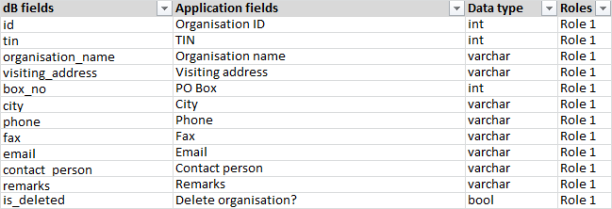
Figure 6. The organisation table with fields, proposed application fields, data types and associated role.

5.4 The audits_inspections table
Figure 7. The control table with fields, proposed application fields, data types and associated role.

5.5 The eias_permits table
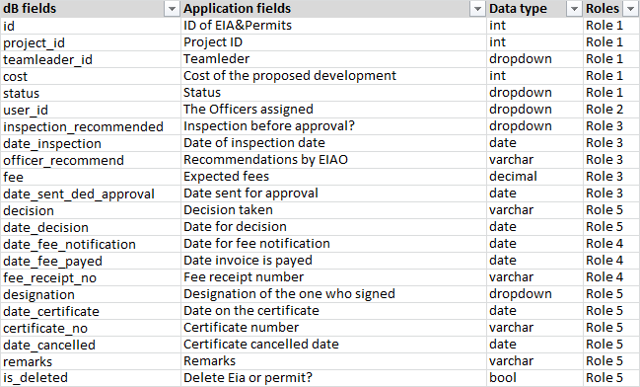
Figure 8. The EIAPermit table with fields, proposed application fields, data types and associated role.

5.6 The documents table
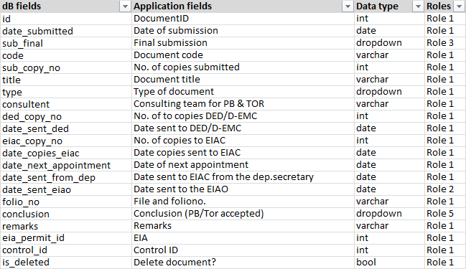
Figure 9. The document table with fields, proposed application fields, data types and associated role.

5.7 The hearings table
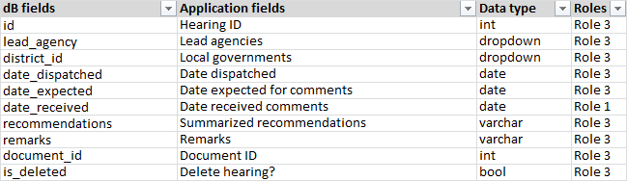
Figure 10. The hearing table with fields, proposed application fields, data types and associated role.

5.8 The practitioners table
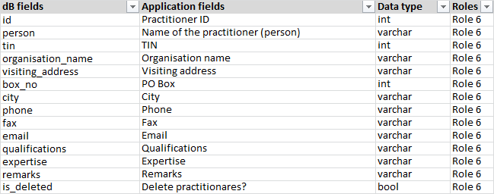
Figure 11. The practitioner table with fields, proposed application fields, data types and associated role.

5.9 The practitioner_certificates table
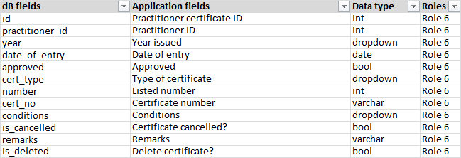
Figure 12. The practitionercertificate table with fields, proposed application fields, data types and associated role.

5.10 The audits_inspections_personnel table
Figure 13. The audits_inspections_personnel table with the different fields.

6. Using the database in the processes

6.1 Practitioners
The Practitioners list contains approved consultants to perform an EIS. The list have to be public available for companies to choose a consultant that have been approved by NEMA. The list is updated annually, and the final list are available from February in the year it is valid. The practitioners list have traditionally been published online on www.nemaug.org as a PDF file.

We have imported the list for 2014. To update this list, persons at NEMA have to update the database with new entries or changes in existing practitioners.

Guide for adding/updating practitioners list:
Add certificates or new practitioners:
- Filter on the name in the existing list to see if the practitioner already is registered
  - If yes, go to step 2
  - If no, add “New practitioner” with all relevant information
- Click on the practitioner and add “New” under certificates
- The date of entry will be today by default. Choose the certificate and conditions from dropdown list and update the information in “Certificate number”. In the certificate number you need to add letters after “E” and update the XXX with correct number.

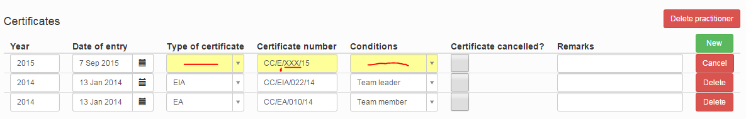

When all the information is registered correct, the yellow color will disappear and the information will be saved in the database.

6.2 Enter data for EIA and Permits
Many users will enter information into the database. Below we suggest the information that could be entered during the life of a project.

Registration:
The assistant receives the documents (project) and enters:
- Date of submission
- Document code
- No. of copies submitted
- Document title
- Type of document
- Consulting team for PB & TOR
- No. of copies to DED/D-EMC
- Date sent to DED/D-EMC
- No. of copies to EIAC
- Date copies sent to EIAC
- Date of next appointment
- Date sent to EIAC from the dep.secretary
- Teamleader
- Cost of the proposed development
- Organisation (TIN, Organisation name, Visiting address, PO Box, City, Phone, Fax, Email, Contact person)
- Project title
- Category of project
- Location name (Address, District, Longitude, Latitude)
- Team members

The EIA-assistant forwards documents to DEMC (and EIAC who forward to third parties)
(DEMC receive the documents and appends instruction notes. Documents are forwarded to EIAC (including submission letter). No registrations.)

Allocation:
EIAC receives the original copy with the submission letter and enters (in review chart (who have received documents))
- Date sent to the EIAO
- The Officers assigned

Review:
Reviewers receive the original documents. Provide own review comments.
Decision whether a project needs a full EIA (Accepted/ Full EIA)
  - PB is accepted and no EIA is needed, ref. Guidelines Annex 2.
  - A letter is written to the developer and they need to hire a consultant and conduct a full EIA, ref. Guidelines Annex 3. A new project has to be sent.

- Final submission
- Inspection before approval?
- Date of inspection date
- Recommendations by EIAO
- Expected fees
- Date sent for approval
- Lead agencies
- Local governments
- Date dispatched
- Date expected for comments
- Summarized recommendations

(Reviewers prepare review letter to lead agencies for review of EIA report. Add record of decision form)
(DEMC receive documents from reviewers for further review. Forwards documents to the ED's office for consideration.)

Decision:
ED's office considers the recommendation and decides on the project.
- Conclusion (PB/Tor accepted)
- Decision taken
- Date for decision

Fee payment:
A project is approved and invoice is created.
- Date for fee notification
- Date invoice is paid
- Fee receipt number

Certificate/rejection:
A certificate is issued by the ED's office.
- Designation of the one who signed
- Date on the certificate
- Certificate number
- Certificate cancelled date

Upload of documents:
EIAC uploads documents, including certificate, conditions for certification and any permit associated with it, to the dB.
- Type of documents (EIA report, PB, conditions, certificate and any permits associated to the EIA). The documents will be hyperlinked.

Guide for registering documents in the EIA database:
A “Project” can have several different «EIA and Permits»
An “EIA and Permit” should have several documents over time.
If we count entries in the database, there should be: Projects < EIA and Permits < Documents

The “EIA and Permit” fields are only concerning the actual EIA process, so the fields:
- Team leader
- Team members
- Cost of the proposed development
should only be added once per EIA. But, the field “Status” must change when you receive new documents (we aim that this status should automatically change).
The “Document” fields are specific for the actual document (PR, TOR or EIA).

I’ll try to clarify with an example:
- You receive a PB from a developer
- Check if the PB relates to an existing project
  - If the project exist, create a new EIA and Permit
  - If the project doesn’t exist, create a new project and then a new EIA and Permit
I now assume that you create a new project and add an EIA and Permit. When creating new projects it is very important to give them a general name like “Karuma Hydropower Plant” so that it is easy to find it again and not specify it to much (like “EIA for Karuma Hydropower Plant project”).
- Add TL, TM and cost, and set the status “PB received”
- Add the document information like document title, final submission, no of copies submitted, type of document etc. The type of document will be “Project Briefs”
- Then, after some time, you will receive a TOR related to the EIA and Permit that you have already created.
- Set the status to “TOR received”
- Add a new document to the already existing EIA and Permit. The type of document will in this case be “TORs for EIA”
- You now have a project with one EIA and Permit that includes two documents (PB and TOR).
- Again, after some time, you will receive the EIA report
- Set the status to “EIS received”
- Create a new document on the existing EIA and Permit and add the information. The type of document will now be “EIA report”.
- In this final step, the remaining fields for the EIA and Permit are filled. Fields like “date of invoicing”, “date invoice is payed”, signature and date on certificate and “certificate number”. An EIA officer should fill these fields.
- The EIA and Permit for this project is now finalized and all information is connected to a project. For this example you will have one Project -> one EIA and Permit -> three documents

So, for each new document you receive from a developer you must:
- Check what kind of document this is.
- If it is a PB you should create a new EIA and Permit (either on an existing project or a new project)
- If it is a TOR or EIA, the EIA and Permit should already exist. You then locate the EIA and Permit (by filtering on projects) and add an new document to this EIA and Permit.

Finding coordinates for a location.
In order to find the correct coordinate for a project location we suggest you use Google maps (https://www.google.co.ug/maps/ ). Example are listed:
- Search for "nema house uganda"
- Zoom to the building
- Right click on the building and choose "What's here?"
- The coordinates will be available in the top left corner, click the link.. (see Figure 13).

The coordinates can be pasted into one field in the application. We will store the information in two fields in the database (datatype decimal).
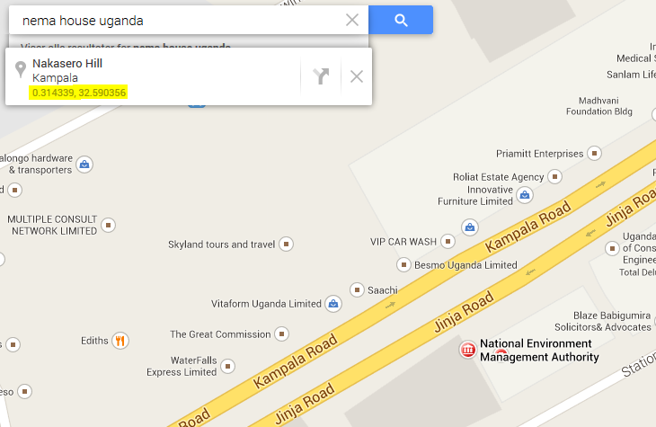
Figure 13. Coordinates to NEMA house from Google maps.

6.3 The EIA process status
A project starts with a PB, and often continues with ToRs and EIS, and subsequent decisions and fee payment. It is a long process. We suggest that the system may indicate the status of each project, - showing where the project is in this process.
The triggers for each main step are (see Figure 14):
- Document quality, whether a final submission has been made.
- Document conclusion, will the project continue with ToR and EIS or will a certificate be issued based on the PB
- Certificate decision, will the project be approved or rejected.

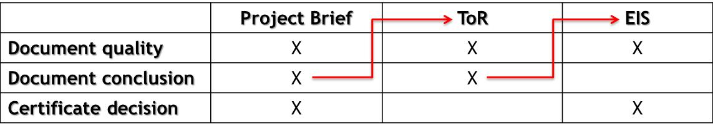
Figure 14. The flow of documents leading to a certificate.

The application should automatically identify the status of the EIA-process. That means that the application uses the information in certain fields to identify the status.

Our suggestion is shown in Figure 15.

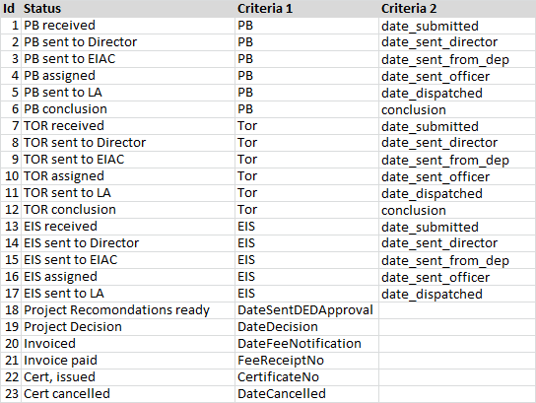
Figure 15. The different process status and criteria that trigger them.

Examples:
- If an EIA work-process of a project is at the stage where the EI Study has just been received, the Status is set to "EIS received".
- If an EIA work-process of a project is at the stage where payment has been received, but a certificate has not yet been issued, the Status is set to "Invoice paid".

The highest triggered status (Id) number will be shown in the application. I.e. if a ToR is dispatched to lead agencies, status ID 11 is triggered and the project status will be "TOR sent to LA".

The field for conclusion for PB and ToRs is a mandatory field. It is however controlled by role=5, so we need to pre-fill a value in this field.
The dropdown values available in this field are:
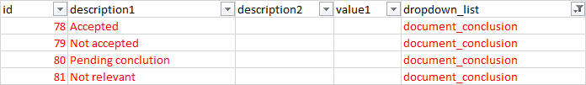
Ideally the value for "Not relevant" should not appear in the drop-down list. This value shoul only be used to "lock" this field for document_type = ID10;11;12
The rules for pre-filling are combined between the values in document_conclusion and document_type:
Default = ID80 for document_type ID8;9
Default = ID81 for document_type ID10;11;12. When ID81 is used, the field should be read-only

6.4 The Audit and Inspection process
NEMA conducts several inspections (compliance inspections) and a few audits (compliance audits). An audit uses several days, initiated by a startup meeting. The reasons for an audit could be:
- Asked by court
- High risk projects
- Licence/Permit is expired

Audit and inspection can use the same database field. Today NEMA do not use a number for an audit or an inspection. We agreed that such a number will be introduced in the EIA database.

- Year
  - Add the year when the audit/inspection was performed or planned to be performed. Default value is present year. Mandatory.
- Number
  - The number will be automatically created based on the year and a serial number. Example, 2015.001 is the first registered audit or inspection in 2015.
- Type
  - Choose audit or inspection from a dropdown list. Mandatory.
- Coordinated
  - Tick the box if it is coordinated with other agencies. (default value is No, i.e. the box is empty)
- Advance notice
  - Tick the box if it is notified to the organisation in advanced. (default value is No, i.e. the box is empty)
- Date carried out
  - Add the date when it was performed. If it is an audit and lasts several days, add the first day.
- Number of days
  - Default value is 1. Change the number if it lasts several days. Mandatory.
- Description of findings
  - Enter the findings. Max characters is 2000. The field becomes mandatory when there is a date in the field action taken date. This means that you can add the findings when you have them, but you will be forced to add them when you have added a date in the action taken date.
- Recommendations
  - Enter the recommendation from the findings. Max characters is 2000.
- Action taken date
  - Add the date for the action taken letter (the action take letter is one of the values in the action taken field)
- Action taken
  - Choose a value from the dropdown list. This is the choice of which action taken letter is to be sent.
- Timeframe for correcting deviations
  - Enter the number of days the organisation have to comply with the deviations. The number of days will include weekends and public holidays.
- Deadline to correct deviations
  - The deadline to correct the deviations will be automatically calculated based on action taken date + timeframe for correcting deviations. The field is read only.
- Date for receiving corrections
  - Add the date when you received the corrections.
- Closing date
  - Add the date for when the audit or inspection is closed.
- Status
  - The status is calculated based on different criteria’s. For details, see next chapter.
- Remarks
  - Enter additional information, if necessary. This could be information you receive by phone from the organisation. Max characters is 2000.

6.5 The Audit and Inspection status
To have an overview of the process, we add a status. This status change is based on different criteria’s. When a number is generated (based on year and a serial number), the status “Created” is automatically generated. When the field “Date carried out” is filled, the status will change to “Carried out” and so on (see Figure 16 for all statuses).

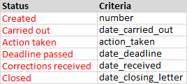
Figure 16. The Audit and Inspection status.

6.6 Support tables
In order to keep the quality of data input as good as possible we introduce different dropdown lists from which to choose data values from. We categorize them for different use, but some can be used in different part of the process. Examples are dropdown lists with value "Yes" and "No" that can be made available in different fields. Also values in the table 'District' (which is considered a support table) can be used in a dropdown list for adding location information on a project and for adding information regarding the results of hearings at local government level.
So, we will use information in so called support tables to create dropdown lists in the application.
Some of the lists will be created using major tables as for instance 'District', 'Practitioner' and 'LeadAgencies', but some dropdown lists are only values to track the flow in the process. These values will be created in a separate table called 'type_codes'.
The different values and the structure are shown in appendix 9.4.

We add some additional information in this table as well. The column 'Value1' show the different deadlines for the project types.
So the table consist of an ID, short name, long name, additional information and the name of the dropdown list.

The User table will function as a support table. This table will contain information regarding logon to the system.
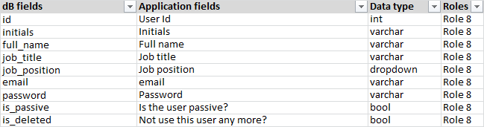
Figure 18. The User table with fields, proposed application fields, data types and associated role.

7. Search

7.1. Why search?
The goal with search functions is normally:
- The user wants to find a specific object, like a project, an EIA, a permit, an audit or an inspection.
- The user wants to study a group of objects, for instance the status of the inspections done in 2015.
- The user wants to create a report.

a) The user can therefore double-click on any row on the resulting list from his search and the application will the show the object. This goal does not need many search criteria, nor many fields on the resulting list from a search.

b) The user can therefore study the information on the resulting list from his search, which includes the possibility to sort the list. This goal needs several search fields or several fields on the resulting list from a search. it’s not easy to identify the search fields / fields on the resulting lists that supports goal b) for a new application. Therefore, the search fields and in particular the fields on the resulting list has to implemented when the users have discovered their needs due time.

c) The user can therefore export the resulting list from his search to Excel. This goal needs very many fields on the resulting list from a search, - but many of them could be invincible.

In general, just some search fields provides a good resulting list:
- Obligatory fields.
- Fields with a drop down list.

7.2. Audit and inspections
a) is the most important goal in 2015, since this search will be the only way to find the audits and the inspections. But based on experience from Norway we have included additional search fields that partly supports goal b) and c).

We suggest these search fields:
- Project title
  - Free text search in a text box.
- Project district
  - One value from a drop down list. The search must include additional districts.
- Category of project
  - One value from a drop down list.
- Developer
  - Free text search in a text box.
- Year
  - Field layout unknown (one solution could be this: “2014;2015” etc. Must be possible to enter several years.
- Number
  - Free text search in a small box.
- Type
  - One value from a drop down list.
- Participants from NEMA
  - One value from a drop down list.
- Action taken
  - One value from a drop down list.
- Status
  - One value from a drop down list.
- Grade
  - One value from a drop down list.

Invincible fields on the resulting list:
- Year
- Coordinated
- Advanced notice
- Date carried out
- Number of days
- Participant from lead agencies etc
- Date of action taken
- Is there a document (Yes/No)
- Timeframe for correcting deviations
- Date for receiving corrections
- Closing date

7.3. EIA and permits
Later.

8. Statistics
The purpose with adding a statistics page is:
- To document the data quality.
- To display some key information to the management.
- To display some key information to the caseworkers.

The production version from October 2015 will include some of these features mentioned in this chapter.

The statistics is located in the top menu, just left of “About”. The statistics can have four tabs, one for each of the subchapters.

8.1 Projects
At the top of the page we can display the total number of projects and developers in the database. Suggested label:
“The EIA database has … projects and … developers. The statistics below shows the number of projects for some key elements.”

We suggest the following statistics for use with projects:
- The number of projects per category, where the category is considered for EIA.
  - Sorting: descending by numbers.
  - Label of the first column: Category.
  - Label of the second column: Number.
  - Display the long name (description_long) of the category.
- The number of projects per category, where the category is likely exempted from EIA.
  - Sorting: descending by numbers.
  - Label of the first column: Category.
  - Label of the second column: Number.
  - Display the long name (description_long) of the category.
- The number of projects with and without coordinates.
  - Sorting: first with, then without coordinates.
  - Label of the first column: Coordinates present.
  - Label of the second column: Number.
  - The first column shall display Yes when a coordinate is present and No if a coordinate is missing.
- The number of projects with and without industrial waste water.
  - Sorting: first Yes, then Unknown and finally No.
  - Label of the first column: Industrial waste water.
  - Label of the second column: Number.
- The number of projects per developer. The list will show the ten developers with most number of projects.
  - Sorting: descending by numbers.
  - Label of the first column: Top ten developers.
  - Label of the second column: Number.
- The number of projects per grade.
  - Sorting: first Red, then Yellow, then Green and finally Unknown.
  - Label of the first column: Grade.
  - Label of the second column: Number.

When the statistics are displayed, you can click on the number to show those projects. The project list will appear below the statistics. You can display this list if the number is less than 500. The reason for this is due to performance issues.

8.2 EIA and Permits

8.3 Audits and Inspections

8.4 Practitioners

9. Follow up
Things to consider …

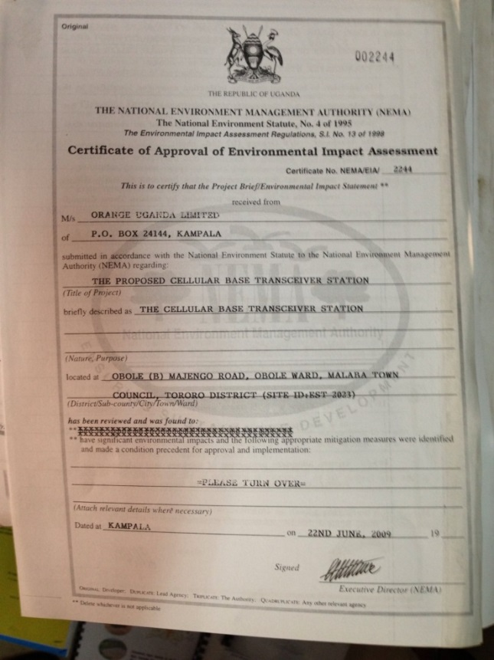
9.1 Documents
Figure 19. Certificate with number, watermark and signature issued by NEMA.
Although the different documents linked to each project should be signed in the different steps of the process, it is functional to have documents available electronically. In this way different case workers could view documents at different steps in the process. For historical reasons it is also user friendly to have access to documents through the EIA database system.

To gain easier access to documents it is necessary to scan them. This will provide a digital copy available in the system. Documents will be uploaded to a file structure on the same server as the database in the "cloud". The upload will be either directly in the application or through a FTP server.

Specification for a scanner:
- Must have automatic document feeder (ADF)
- Must scan duplex
- Must scan to PDF
- Should have OCR technology
- Should have network card
- Should be fast (20-30 spm)

By use of a FTP server it is possible to upload documents every night to avoid use of bandwidth during the daytime.

Documents will be accessible from the system using a hyperlink that is generated by the application.

The following documents could be scanned and made available:
- Certificates + conditions (about 10 pages)
- Permits (up to 15 pages)
- Inspections (up to 15 pages)
- Audits (up to 15 pages)
- Letters from the lead agencies (up to 15 pages)
- Old EIA-reports (large documents!)

The issuing of a certificate is the final step of the EIA review process. Certificates are created with a typewriter using a special paper with watermark. The paper also have preregistered certificate number. The certificate is scanned for electronically archiving.

The system could generate the certificate, but then it would be without preregistered number, watermark and signature. Probably better to scan the original document and upload it to the database.

After upload the certificate will be available to users through a hyperlink.

9.2 Permits
A project could have several permits, some of the given by NEMA. Information about the permitting process could hopefully be recorded in this new database. How best to do that depends on whether there are similarities between the EIA-process and the permitting process. If, for instance, the permitting process includes documents, hearing and fee payment, the main table could probably be reused.

9.3 Audits done by the project (the organisations)
At the moment, we do not have enough information to identify how this process should be recorded in the database.

9.4 Laboratory
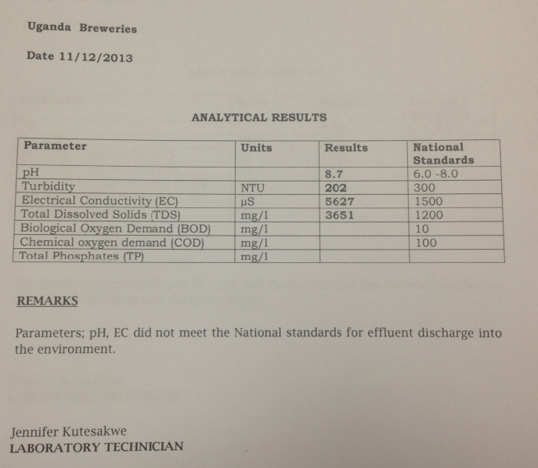
For projects that create waste water the NEMA laboratory takes samples and either do the analysis or send the sample to another laboratory for analysis. The projects that create waste water are identified at the registration step.
Figure 20. Analytical results.

The analysis document (see Figure 18) could be uploaded to the project so that it is available for later review. We could, at a later stage, add the analysis results in the database if this is needed.

Data from analytical reports can be added in the existing tab called “Reports”. Her we will have data and also access to the scanned analytical report document.

9.5 External support/maintenance
We have discussed future support and maintenance of the database with an external consultant located in Kampala.
Mr. Reinier Battenberg from Mountbatten Ltd. is willing to take on such a task. The address for the company is:

Reinier Battenberg
Moutbatten Ltd.
Plot 7669
Kyandondo Block 244
Phone 256312283937

10. Appendix

10.1 Hosting database in the cloud
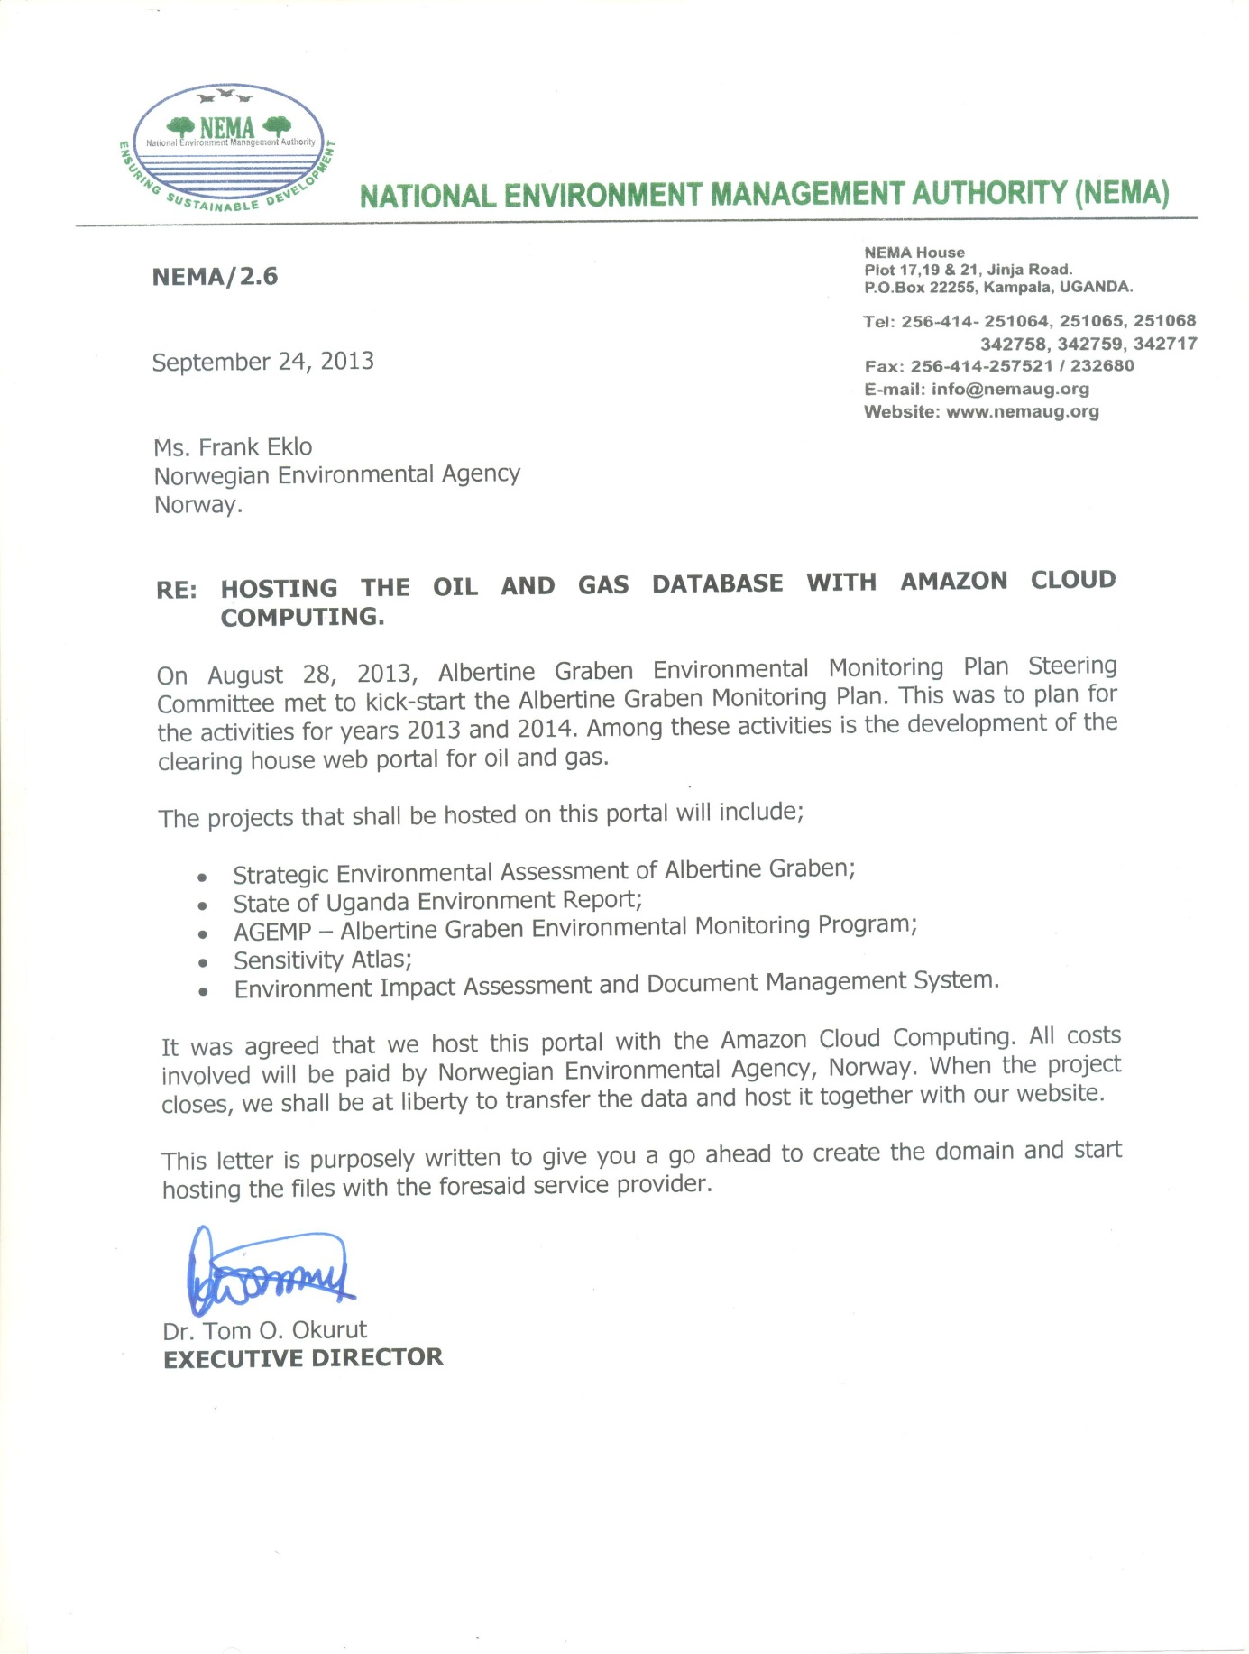

10.2 Process description

10.3 Database model

10.4 The codes table
id | description1 | description2 | value1 | dropdown_list
1 | Approved |  |  | decision
2 | Rejected |  |  | decision
3 | Disregarded |  |  | decision
4 | Re-submitted |  |  | submission
5 | Final submission |  |  | submission
6 | Considered for EIA |  |  | consequence
7 | Likely exemptet from EIA |  |  | consequence
8 | PB | Project Briefs | 21 | document_type
9 | EIATOR | TORs for EIA | 14 | document_type
10 | EIA | EIA Reports | 30 | document_type
11 | EATOR | TOR for EA | 14 | document_type
12 | EA | Audit Reports | 21 | document_type
13 | ESMP | ESMP | 0 | document_type
14 | VALUE NOT IN USE
15 | PB received |  |  | eia_status
16 | PB sent to director |  |  | eia_status
17 | PB sent to EIAC |  |  | eia_status
18 | PB assigned |  |  | eia_status
19 | PB sent to LA |  |  | eia_status
20 | PB conclusion |  |  | eia_status
21 | TOR received |  |  | eia_status
22 | TOR sent to director |  |  | eia_status
23 | TOR sent to EIAC |  |  | eia_status
24 | TOR assigned |  |  | eia_status
25 | TOR sent to LA |  |  | eia_status
26 | TOR conclusion |  |  | eia_status
27 | EIS received |  |  | eia_status
28 | EIS sent to DED |  |  | eia_status
29 | EIS sent to director |  |  | eia_status
30 | EIS assigned |  |  | eia_status
31 | EIS sent to LA |  |  | eia_status
32 | Project Recomondations ready |  |  | eia_status
33 | Project Decision |  |  | eia_status
34 | Invoiced |  |  | eia_status
35 | Invoice paid |  |  | eia_status
36 | Cert. issued |  |  | eia_status
37 | Cert. cancelled |  |  | eia_status
38 | TL | Team leader |  | practitioner
39 | TM | Team member |  | practitioner
40 | Yes |  |  | yes_no
41 | No |  |  | yes_no
42 | Unknown |  |  | yes_no
43 | Red |  |  | grade
44 | Yellow |  |  | grade
45 | Green |  |  | grade
46 | Blue |  |  | grade
47 | Unknown |  |  | grade
48 | Audit |  |  | audit_inspection_type
49 | Inspection |  |  | audit_inspection_type
50 | EIA | Environmental Impact Assesment |  | cert_type
51 | EA | Environmental Audits |  | cert_type
52 | EP | Environmental Partnership |  | cert_type
53 | PA | Partnership |  | practitioner
54 | ESMP received |  |  | eia_status
55 | ESMP sent to director |  |  | eia_status
56 | ESMP sent to EIAC |  |  | eia_status
57 | ESMP assigned |  |  | eia_status
58 | ESMP sent to LA |  |  | eia_status
59 | ESMP conclusion |  |  | eia_status
60 | USD | US Dollar |  | currencies
61 | GBP | British Pound |  | currencies
62 | EUR | Euro |  | currencies
63 | CNY | Chinese Yuan |  | currencies
64 | UGX | Ugandan Shilling |  | currencies
65 | Administrativ letter |  |  | action_taken
66 | Compliance agreement |  |  | action_taken
67 | Improvement notice |  |  | action_taken
68 | Restoration order |  |  | action_taken
69 | Closure |  |  | action_taken
70 | Created |  |  | audit_inspection_status
71 | Carried out |  |  | audit_inspection_status
72 | Action taken |  |  | audit_inspection_status
73 | Deadline passed |  |  | audit_inspection_status
74 | Corrections received |  |  | audit_inspection_status
75 | Closed |  |  | audit_inspection_status
76 | Action letter |  |  | audit_inspection_document_type
77 | Documentation |  |  | audit_inspection_document_type

According to the "Guidelines for environmental impact assessment in Uganda" - 1997
A summary statement of the nature of projects, its proposed environmental impacts and the likely environmental impacts and mitigation measures thereto.
NEMA is currently establishing an office in the Graben area.
The EIA reports are now being delivered by CD-rom, but old ones are archived as large documents.

